Barnes County Community Health Profile
POPULATION
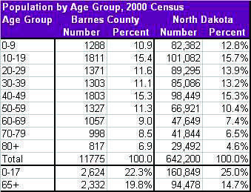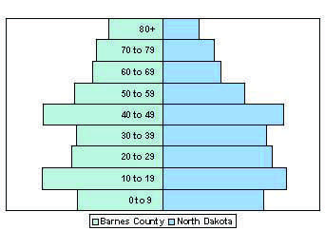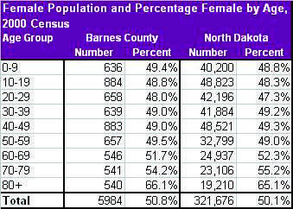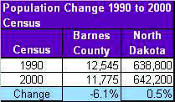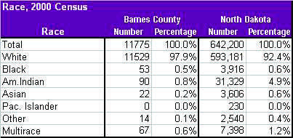
Barnes County Community Health Profile
POPULATION
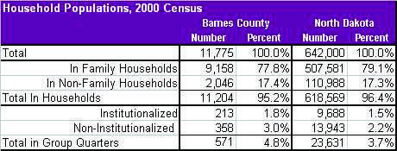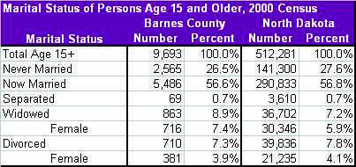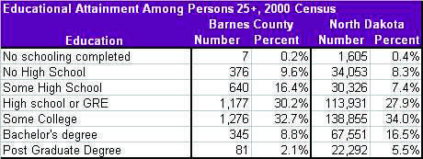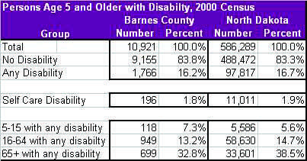
Barnes County Community Health Profile
POPULATION
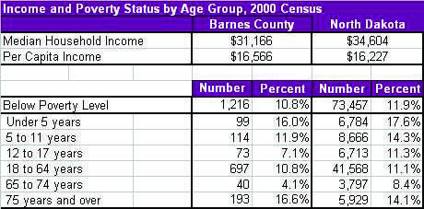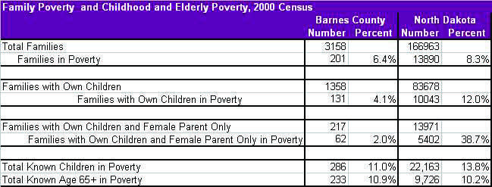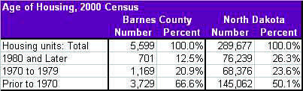
Barnes County Community Health Profile
Vital Statistics Data BIRTHS AND DEATHS
Adj. Rate = Age Adjusted Rate
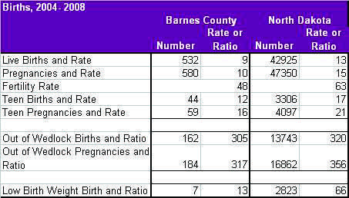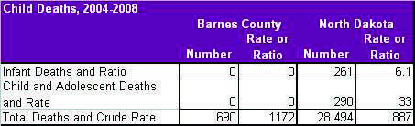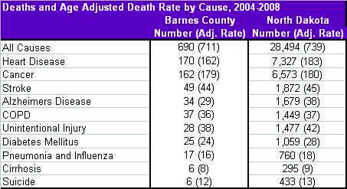
Barnes County Community Health Profile
Vital Statistics Data BIRTHS AND DEATHS
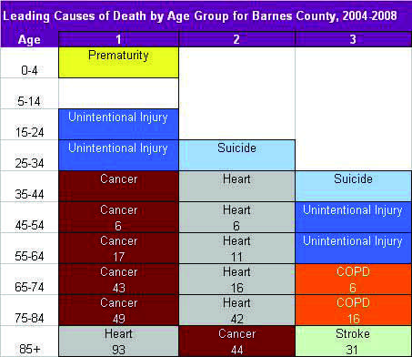
Barnes County Community Health Profile
ADULT BEHAVIORAL RISK FACTORS, 1999-2007
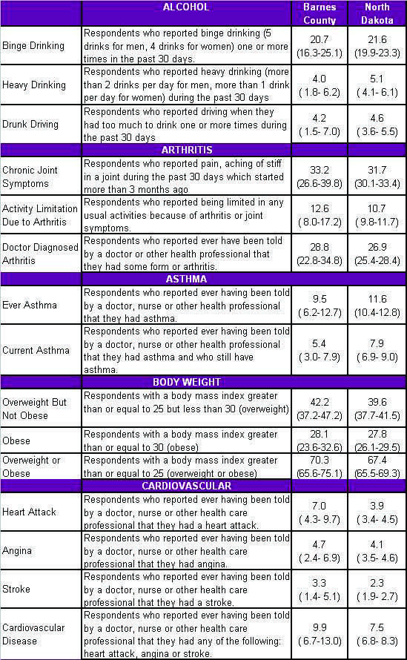
Barnes County Community Health Profile
ADULT BEHAVIORAL RISK FACTORS, 1999-2007
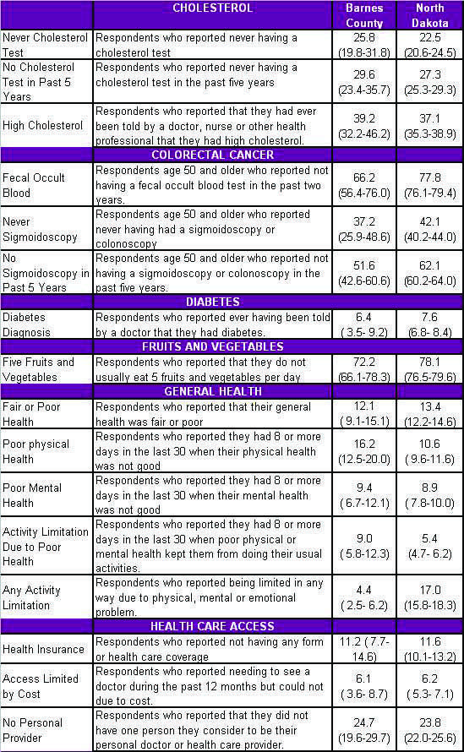
Barnes County Community Health Profile
ADULT BEHAVIORAL RISK FACTORS, 1999-2007
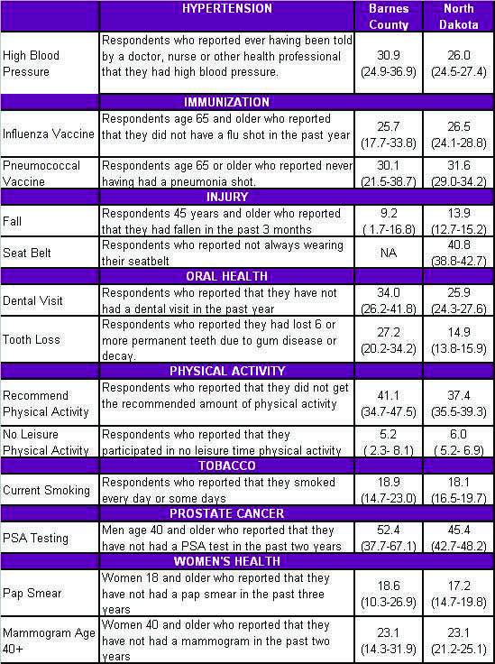
Barnes County Community Health Profile
CRIME
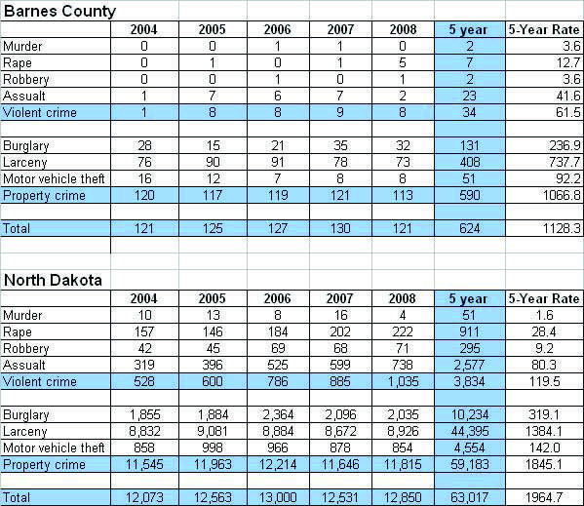
Barnes County Community Health Profile
CHILD HEALTH INDICATORS
